# Do girls underestimate their digital skills? Gender differences in digital self-efficacy in the Chilean school context

**Abstract**

A series of studies reveal that, in the majority of secondary school systems, male students consistently demonstrate higher technological self-efficacy than their female counterparts. Paradoxically, female students achieve significantly higher scores in international standardized computer literacy tests, raising the question: Do girls underestimate their digital abilities? This study focuses on gender differences in digital self-efficacy in three main aspects: a) a contrast between general and specialized self-efficacy, b) control gender differences in self-efficacy by performance in a digital abilities test, and c) gender composition effects, this is, whether the proportion of females in the classroom affects girls (and boys) self-efficacy. We estimate a series of multilevel models (random effects) using data from the Chilean ICILS (International Computer and Information Literacy Study) 2018 database, comprising 178 schools and 3092 students. Our results suggest that girls exhibit lower self-efficacy for the use of advanced technological applications, even under control of performance in a digital literacy standardized test. However, and contrary to our initial hypothesis, female students show less confidence when surrounded by a larger proportion of girls in the classroom.

**Keywords:** ICT self-efficacy, Gender, Chile, Classroom composition, ICILS

# 

# Introduction

With the proliferation of digital technologies, educational systems worldwide have transformed profoundly, making ICT knowledge and skills critical for navigating modern society. ICT competencies include computer literacy, coding, internet navigation, and critical thinking in digital environments, all recognized as vital for educational success and future career opportunities (Mahmud & Wong, 2022). Despite widespread technology integration in classrooms, significant disparities remain in ICT acquisition, disproportionately affecting marginalized groups and limiting their participation in an increasingly digital society (Dodel, 2021). Socioeconomic status plays a major role in these disparities, as children from lower-income families face barriers such as limited internet access, outdated school technology, and insufficient digital learning resources (Butcher & Curry, 2022; Mulyaningsih et al., 2021). Parental education and involvement further exacerbate inequalities, with higher-educated parents providing more exposure to and support for ICT learning (O’Hara, 2011). Cultural stereotypes and gender norms also shape skills development, often discouraging girls from pursuing computer science and engineering (Cheryan et al., 2015; Clayton et al., 2009; Wong & Kemp, 2018). These stereotypes, reinforced through socialization in schools, emerge early and limit girls’ opportunities for digital learning (Varoy et al., 2023).

Self-efficacy, defined as confidence in one’s ability to handle challenges and achieve goals (Bandura, 1982), is essential for mastering digital skills. However, societal norms often undermine girls' digital self-efficacy, associating technology with masculinity and reducing their confidence and motivation (Hargittai & Shafer, 2006). Boys, in contrast, frequently receive encouragement, boosting their self-efficacy and persistence (Broos, 2005; Wong & Kemp, 2018). Family and peer socialization reinforce these gendered attitudes, perpetuating differences in digital participation and achievement.

Chile exemplifies gender disparities in ICT. While female enrollment in higher education surpasses male enrollment by 6.9%, male enrollment in ICT-related degrees exceeds female enrollment by 65.7% (Guzmán, 2021; SIES, 2021). High dropout rates among women in computer-related fields are linked to psychological factors such as low self-esteem, academic inefficiency, and lack of encouragement during secondary education (de la Fuente-Mella et al., 2020; González Catalán et al., 2018). Consistent with regional educational literature, understanding the school stage is critical to addressing gender inequalities in self-efficacy and digital literacy that shape higher education and occupational outcomes (Ancheta-Arrabal et al., 2021).

This paper explores Chilean gender differences in school-age digital literacy, focusing on ICT self-efficacy. It examines (1) differences between general and specific self-efficacy, (2) the paradox of girls performing better on standardized ICT tests but reporting lower self-efficacy (Fraillon et al., 2014; Gebhardt et al., 2019; Punter et al., 2017), and (3) the role of classroom gender composition, arguing that classrooms with more girls foster higher self-efficacy among them by counteracting stereotypes.

# Self-efficacy and ICT (Information and Computer Technology)

One key psychological construct related to ICT is self-efficacy. Defined by Bandura (1982) as “beliefs in one’s capabilities to organize and execute the courses of action required to produce given attainments” (p. 3), self-efficacy refers to individuals’ perceptions of their abilities, shaping decisions and actions. Those who believe they can succeed in an activity are more likely to persist through obstacles (Bandura, 1982). It distinguishes between motivation to perform a task based on expected outcomes (outcome expectancy) and perceived capability to accomplish it (self-efficacy). As Bandura (1977) stated: “Individuals can believe that a particular course of action will produce certain outcomes, but if they entertain serious doubts about whether they can perform the necessary activities, such information does not influence their behavior” (p.193). Positioned early in the chain of predictors for performance and behaviors, self-efficacy significantly influences learning processes in fields like education (Wray et al., 2022) and health (Mata et al., 2021).

The four sources of self-efficacy—mastery experience, emotional states, vicarious experiences, and social models—are grouped into individual (mastery and emotional) and social comparative factors (Bandura, 1997; Usher & Pajares, 2008). Mastery experience, or previous skills, strongly affects self-efficacy, while negative emotions such as anxiety and stress undermine it.

Self-efficacy is also critical for digital technologies. Concepts such as digital skills (Correa, 2016; van Dijk & Deursen, 2014), digital competence (Zhao et al., 2021), and ICT literacy (Reddy et al., 2020) describe abilities in this realm. While early frameworks emphasized technical skills, newer approaches focus on critical thinking, creativity, and social abilities (Correa et al., 2024; Helsper, 2021). Fraillon et al. (2014) proposed a multidimensional framework for ICT competencies in the International Computer and Information Literacy Study (ICILS), conducted since 2013. ICILS assesses skills in understanding computer use, gathering and producing information, and digital communication, with computational thinking added in 2018 (Fraillon et al., 2020). Unlike self-reported skills, ICILS measures performance through tasks.

Digital self-efficacy combines self-efficacy and digital literacy, defined as individuals’ belief in their ability to perform specific ICT actions to achieve goals (Eastin & LaRose, 2000). It predicts digital competencies, including internet use frequency and online activities, particularly among male teens (Broos & Roe, 2006; Livingstone & Helsper, 2007). General self-efficacy refers to broader beliefs about abilities, while specific self-efficacy relates to distinct tasks (Agarwal et al., 2000). General self-efficacy is often a broader disposition based on experiences (Schwoerer et al., 2005).

ICT knowledge, as a mastery experience, is essential to building self-efficacy. Evidence shows that training (Downey & Kher, 2015), computer science courses (Revelo et al., 2016), computer serious games (Power, Lynch & McGarr, 2020), and ICT use experience (Hatlevik et al., 2018) improve self-efficacy. In schools, higher computer literacy boosts basic ICT self-efficacy but not advanced self-efficacy (Fraillon et al., 2020). Gender gaps persist, with girls outperforming boys in computer literacy in cross-national studies (Fraillon et al., 2014).

# Gender and Self-efficacy

Empirical evidence consistently shows that girls tend to feel less confident than boys in their ability to use ICTs (Broos, 2005; Gebhardt et al., 2019; Hargittai & Shafer, 2006), as in attitudes towards ICTs access, interest, and enjoyment of technologies, and computer use intention for study and labor, among others (Cheryan et al., 2015; Cussó-Calabuig et al., 2018). Most theories attempting to explain such differences are related to concepts of prejudices and stereotypes about gender, which at the same time can affect individual perceptions of self-efficacy.

Stereotypes are beliefs shared and acquired within societies about the characteristic properties of people classified into particular social categories or groups. They can shape social life and affect the way we treat individuals, who are expected to have certain traits, role behaviors, occupations, and physical characteristics based on attributes such as gender, ethnicity, or age (Eagly & Koenig, 2021; Haines et al., 2016). Gender stereotypes are generalizations of what women and men are like and should be like (Heilman, 2012). These traits translate into work domains and expected roles, and, for instance, women are more often associated with arts and family, and men with science and physical labor (Heilman, 2012; Tellhed et al., 2023). While gender stereotypes are not static, they have been shown to inform expectations about men's and women’s interests and talents and even people’s career aspirations (Eagly et al., 2020). This includes expectancies of success —that is, self-efficacy. Generally, girls and women show low levels of self-efficacy in stereotypically male activities and men-dominated domains, including technology and computer sciences spaces, even when their actual performance is not necessarily worse (Broos, 2005; Gebhardt et al., 2019).

Various theories have attempted to understand this gender gap, considering self-efficacy consistent with the gender stereotypes framework. For instance, the Expectancy-Value Theory (EVT) postulates that “achievement-related choices are motivated by a combination of people’s expectations for success and subjective task value in particular domains” (Leaper, 2011). In it, the expectation of doing well (combined with the value of the activity) could make it more likely to be involved in activities. Similarly, the Stereotype Threat Theory (STT) highlights the expectation of performance. It proposes that when there is a stereotype about the poor performance of a minority group in a relevant task, members of that group tend to confirm the stereotype, particularly in more complex tasks (Koch et al., 2008). In this case, women tend to be perceived as worse performers in computer use (Smith et al., 2005), which would be consistent with the results observed in interest or ICT self-efficacy. Aligned with social modelling sources of self-efficacy, the Social Role Theory (SRT) argues that gender stereotypes derived from the roles men and women occupy can affect achievement expectations, ability beliefs, or interests (Tellhed et al., 2023). According to the SRT, the fact that ICTs are associated with more masculine traits affects interest and expectations in studying and participating in ICT-related occupations (Sáinz et al., 2016). Girls tend to perceive work in ICTs as antisocial, very technical, detached from social needs, lacking social skills, and individualistic (Sáinz et al., 2012), which would diverge from stereotypes associated with women. Along these lines, it is argued that girls have less exposure to female roles that could model their participation in ICTs (Cussó-Calabuig et al., 2018).

As the STT suggests (Koch et al., 2008; Master & Meltzoff, 2020), confirmation tends to occur with more complex tasks. By distinguishing between basic ICTs versus more complex tasks requiring more training, boys tend to show even greater self-efficacy than girls in advanced tasks (Busch, 1995; Liu & Chang, 2010). For Cassidy and Eachus (2002), a possible explanation is that more complex tasks tend to be perceived as more masculine, which would partly explain the observed result. In contrast, Hatlevik et al. (2018) report that girls show higher levels of self-efficacy in ten out of fourteen analyzed countries, concluding that the image of boys being more self-confident than girls could be decreasing in some countries. However, it is relevant to mention that the analyzed self-efficacy scale refers to basic tasks, such as editing text or finding internet information (Fraillon et al., 2020).

In sum, evidence points to higher self-efficacy of boys compared to girls but also higher achievement by girls, which posits the question of how these two factors interact. Evidence suggests that boys tend to overestimate their own ICT literacy, while girls tend to underestimate it (Punter et al., 2017). Consequently, the expected interaction is that higher computer literacy would increase gender gaps in ICT self-efficacy. In that case, high levels of achievement could increase the boys’ confidence in their ICT abilities, and conversely, low levels of achievement could decrease girls’ confidence in ICT abilities.

Arguably, gender socialization and stereotypes influence the types of activities boys and girls practice, their interests, and the achievements they may accomplish, which reflects and perpetuates gender roles and gender gaps. Therefore, we posit the following hypotheses:

* H1: Female students will show lower digital self-efficacy than male students.
* H2: As computer literacy increases, digital self-efficacy will increase.
* H3: When computer literacy increases, female students will have a lower increase of digital self-efficacy than males.

# School level. Composition effect theories (Gender and performance of classmates)

People’s social comparisons also affect their perceived self-efficacy. Based on social approaches to learning and performance, scholars have proposed that people can build or undermine their self-efficacy by vicarious experiences of observing others’ performances and proficiency. This occurs mainly in comparison to those perceived as having similar attributes, such as gender and age (Ahn et al., 2020; Schunk, 1987). For instance, if individuals observe that their classmates did poorer than them, their self-efficacy will likely improve and vice versa. These social comparative factors are more influential in middle school when young people are more aware of social comparative information (Eccles et al., 1984).

When considering classroom composition, it is crucial to understand that it encompasses various factors that can significantly influence the learning environment and student outcomes —such as digital self-efficacy (Tan, Wu & Ma, 2024). Classroom composition refers to a classroom’s demographic, social, and academic makeup, including student attributes aggregated at the class level (Hochweber et al., 2014). Research has shown that classroom composition can impact peer interactions, instructional behavior, and student achievement (Klusmann et al., 2016). Additionally, classroom composition has been linked to developing antisocial behavior, motivation, language development, and executive function skills among students (Barnes et al., 2023; Guo et al., 2014; Rjosk et al., 2015). In this sense, changes in classroom composition, such as mixing students, can affect stability, peer interactions, and peer victimization within the classroom (Graham, 2006; Rambaran et al., 2020). Furthermore, the distribution of student abilities within a classroom, known as heterogeneous grouping, has positively affected academic achievement and social interactions (Rjosk et al., 2015).

Classroom composition, particularly regarding gender balance, can significantly influence the acquisition and development of skills among school-age children. For instance, Schneeweis & Zweimüller (2012) reported that a higher share of girls in schools led to less likelihood of choosing female-dominated school types, whereas Alan et al. (2018) discovered that girls taught by teachers with traditional gender views had lower performance in math and verbal tests. In contrast, Tillmann & Comim (2023) identified a positive relationship between scholastic achievement and the proportion of female students. This suggests that more girls in the classroom can improve student behavior and academic potential.

Few studies precisely assess the effects of gender composition on technological self-efficacy around educational contexts. At the university level, Busch (1996) found that groups composed mostly of women tend to have more cooperative members than groups composed mostly of men to perform computational tasks related to management careers. However, women majority groups also have lower levels of computational self-efficacy, less previous experience with computers, and less previous encouragement to work with computers. At the secondary education level, through a multilevel exploration, Meelissen & Drent (2008) argue that gender disparities (in favor of boys) in the development of positive attitudes towards technologies are buffered to the extent that there is less presence of students promoting gender stereotypes and more female teachers teaching at school. In line with these findings, it would seem that as the level of female students increases, the students’ self-efficacy levels in the school as a whole tend to decrease. However, if it is assumed that male students are the ones who mostly diffuse gender stereotypes with technologies, it could be hypothesized that as the number of female peers in the classroom increases, female students would feel more confident with their knowledge and skills with technologies.

Taking the previous arguments and evidence into account, the corresponding hypotheses are:

* H4: A larger proportion of girls in the classroom increases girls’ self-efficacy.
* H5: Given gender stereotypes, girls will show lower self-efficacy than boys in classrooms with a higher average computer literacy level.

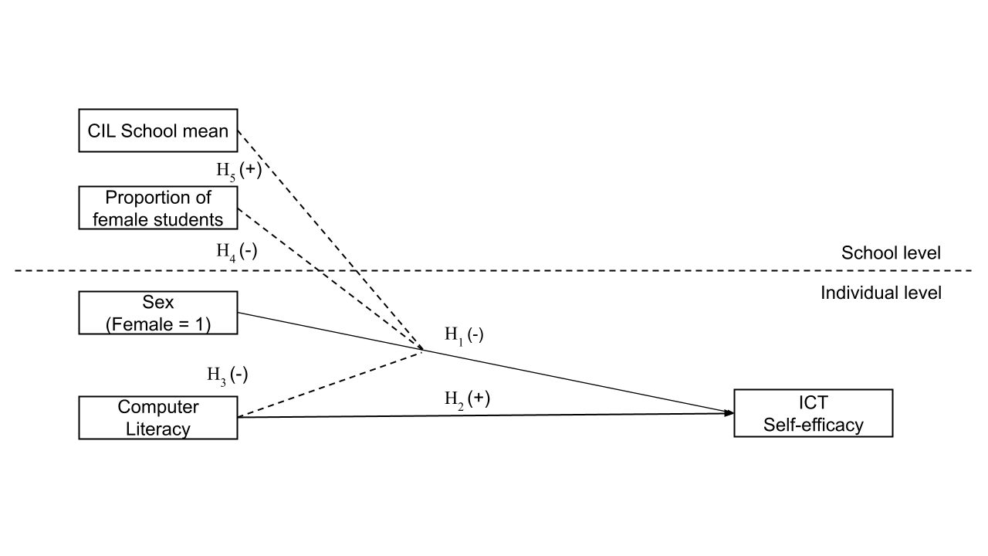

*Figure 1. Hypotheses*

# Data, variables and methods

***Data and sample***

The International Computer and Information Literacy Study (ICILS) was conducted by the International Association for the Evaluation of Educational Achievement (IEA) in 2018. The study sampled eighth-grade students using a random multistage stratified cluster design to ensure representativeness across all participating countries at the school and student levels. The analysis focuses exclusively on the Chilean subset of the ICILS 2018. The sample comprised 3,092 students distributed across 178 schools.

ICILS employed twoinstruments to collect students data. Participants first took a Computer Literacy test with multiple-choice items, assigning each student a Computer and Information Literacy (CIL) score based on their responses. Next, students completed a questionnaire about their home background, values, beliefs, attitudes, and behaviours related to Computer and Information technologies.

***Variables***

*Student level*

*General and Specialized ICT Self-efficacy:* The ICILS student data encompasses two indices of digital self-efficacy: one for general or basic applications and the other for advanced or specialized tasks. Both indices were constructed using the same battery with the question: How well can you do this task *when using ICT?*, and the answers were: *1. I know how to do this, 2. I have never done this, but I can work out how to do this, and 3. I do not think I could do this.* The item's missing values distribution can be examined in Table 1.

**Table 1.** *ICT Self-efficacy items (Dependent variables)*

|  |  |
| --- | --- |
| Label | Valid |
| Suggested as General ICT Self-efficacy | |
| Edit graphic images | 2990 (96.7%) |
| Write or edit text | 2961 (95.8%) |
| Search and find information on internet | 2956 (95.6%) |
| Create multi-media presentation | 2950 (95.4%) |
| Upload multimedia to an online profile | 2937 (95.0%) |
| Insert an image into a document/message | 2901 (93.8%) |
| Install a program/app | 2899 (93.8%) |
| Judge internet information veracity | 2868 (92.8%) |
| Suggested as Specialized ICT Self-efficacy | |
| Create a database | 2972 (96.1%) |
| Build a webpage | 2959 (95.7%) |
| Create a computer program/app | 2960 (95.7%) |
| Set up a local area network | 2938 (95.0%) |

*Note.* Data derived from the 2018 ICILS study.

The construction of both self-efficacy indices suggested by IEA was validated at international level, with a comparative approach between countries.. Both indexes were constructed by the IEA using the Weighted Likelihood Estimation Method, where scores have a mean of 50 and a standard deviation of 10, based on equal weights for all countries. A higher index value indicates a higher level of self-efficacy.

*Computer and Information Literacy:* The CIL scale used in the analyses is based on a test applied by IEA. The test consists of a computer application with a set of five modules, in which each student has to respond to two randomly selected. Every module has 30 minutes of assessment. The structure of a module consisted of a set of questions and tasks based on a realistic theme and following a linear narrative structure. These modules have a series of small discrete tasks (typically taking less than a minute to complete) followed by a large task that typically took 15 to 20 minutes to complete.

The five modules measured different Computer Abilities: website construction, digital file management and collection, database building and mapping tools, desinging content for social network, and information research on the internet.

The ICILS CIL reporting scale was established in ICILS 2013, with a mean of 500 (the average CIL scale score across countries in 2013) and a standard deviation of 100 for the equally weighted national samples that met IEA sample participation standards in the first cycle (2013).[1] Due to the large magnitude this variable in comparison with the others used, the scale had to be multiplied by 0.1 to make the results more intelligible. The higher the value of the scale, the higher the CIL of the student.

*Control variables:* The analysis includes control variables that tend to be influential in studies of educational and technological inequalities. These variables encompass family socioeconomic status - by the highest level of parental education (ISCED Scale) - and the number of books in the household.

**Table 2.** *Individual Variables Descriptives*

|  |  |  |  |
| --- | --- | --- | --- |
| Label | Stats / Values | Freqs (% of Valid) | Valid |
| Sex of student | 1. Boy 2. Girl | 1519 (49.1%) 1573 (50.9%) | 3092 (100.0%) |
| Computer and Information Literacy Score | Mean (sd) : 48 (8.8) min < med < max: 14 < 49 < 76 IQR (CV) : 12 (0.2) | 3092 distinct values | 3092 (100.0%) |
| Highest ISCED of parents | 1. ISCED level 2 not complete 2. ISCED level 2 3. ISCED level 3 4. ISCED level 4 or 5 5. ISCED level 6, 7 or 8 | 53 (1.7%)  266 (8.7%) 1064 (34.8%) 626 (20.5%) 1048 (34.3%) | 3057 (98.9%) |
| Home literacy index | 1. None or very few (0–10 books) 2. Enough to fill one shelf 3. Enough to fill one bookcase 4. Enough to fill two bookcases 5. Enough to fill three or more | 774 (25.2%)  942 (30.7%)  758 (24.7%)  315 (10.3%)  279 (9.1%) | 3068 (99.2%) |

*Note.* Data derived from the 2018 ICILS study.

*School level*

The study took into account two contextual variables to develop multilevel analyses. The first is the average score on the Computer and Information Literacy test at school, which was estimated by aggregating students’ scores by mean. The second is the gender composition of the school, which is estimated by dividing the total number of eighth-grade female students by the total number of eighth-grade students in the school. According to the resulting ratio of female students, schools were classified into three categories: Masculinized when they have less than one-third of girls, Feminized when this proportion is more than two-thirds, and mixed when the girls’ proportion lies in between. Table 3 details frequencies and descriptive statistics of these variables.

**Table 3** *School Variables Descriptives*

|  |  |  |  |
| --- | --- | --- | --- |
| Label | Stats / Values | Freqs (% of Valid) | Valid |
| School mean score CIL test | Mean (sd) : 48 (6.2) min < med < max: 21 < 48 < 61 IQR (CV) : 9.7 (0.1) | 178 distinct values | 178 (100.0%) |
| School gender composition | 1. Masculinized school (0-33) 2. Mixed school (34%-66% gir) 3. Feminized school (67%-100) | 10 (6.1%)  134 (82.2%)  19 (11.7%) | 163 (91.6%) |

*Note.* Data derived from the 2018 ICILS study.

***Methods***

The analysis consists of two stages. The first one explores differences in self-efficacy by gender as well as their correlations with the key variables of the study. The second stage estimates a series of multilevel (random-effects) models (Hox et al., 2017; Vijver et al., 2008).

# Results

The analysis begins by showing descriptive results for the self-efficacy items, as displayed in Figure 2. Notably, across all tasks, a significant proportion of students —no less than 65%— expressed confidence in their ability to perform general tasks, while fewer than 10% reported an inability to do so. On the whole, participants demonstrated a high level of general self-efficacy. In contrast, when it comes to specialized self-efficacy, less than 30% of students confidently state their proficiency in tasks such as building a webpage or creating a computer program. This percentage increases a little regarding tasks like setting up a local area network (31%) or creating a database (35%). Therefore, and as it could be expected, students tend to perceive having fewer skills in advanced than in basic ICT tasks.

**Figure 2** *General and specialized ICT self-efficacy.*

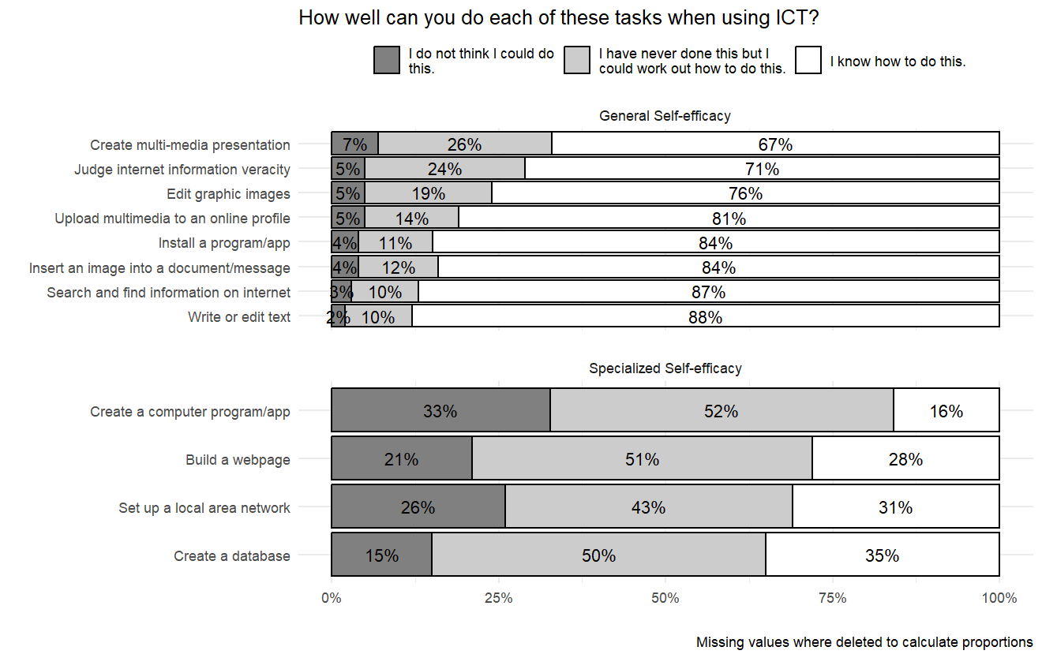

*Note.* Data derived from the 2018 ICILS study.

Turning to gender differences in self-efficacy, Figure 3 compares male and female students, displaying the proportion of those answering “I know how to do this” in each gender group. Whereas girls outperform boys in most of the general self-efficacy items, the opposite occurs for the specialized ones. While most of the differences are statistically significant, they tend to be larger for the specialized self-efficacy in favor of boys.

**Figure 3** *General and specialized ICT self-efficacy by gender.*

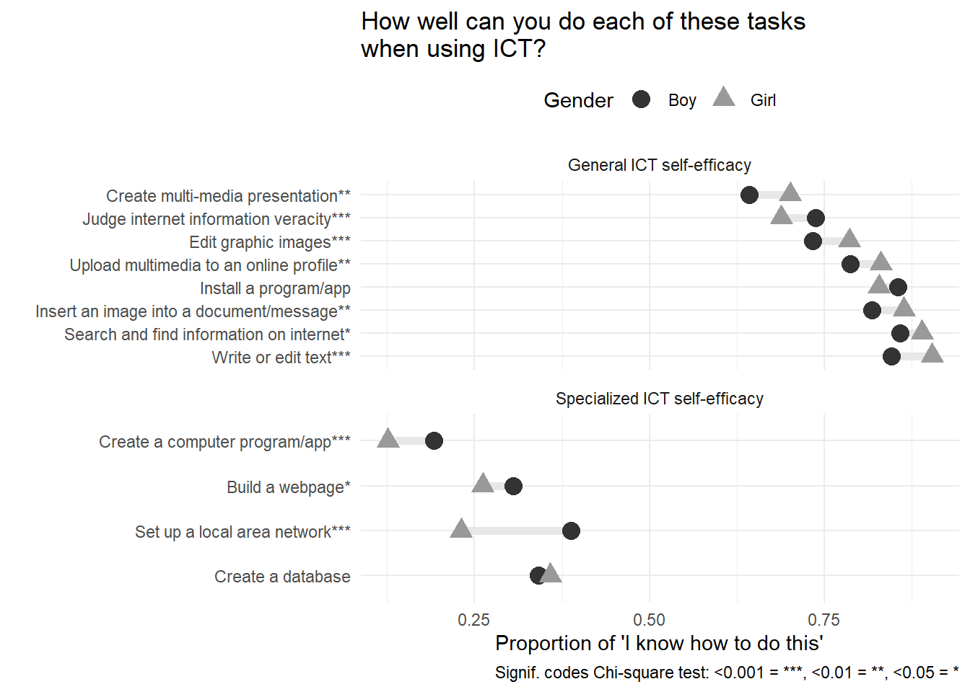

*Note.* Data derived from the 2018 ICILS study.

Figure 4 shows differences in general and specialized self-efficacy according to the gender composition of the schools. Regarding general self-efficacy, we observe that the outperformance of girls is larger in feminized schools, whereas the opposite occurs for specialized self-efficacy: girls underperform boys in feminized schools.

**Figure 4** *ICT self-efficacy and CIL by student sex and school composition.*

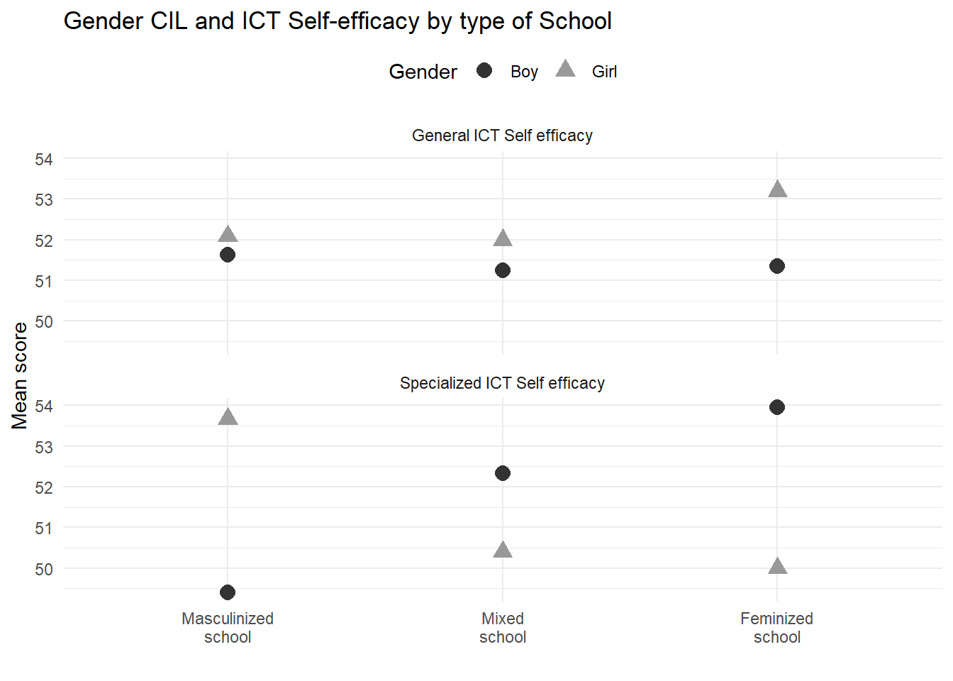

*Note.* Data derived from the 2018 ICILS study.

Table 4 and Table 5 displays the results of the multilevel regression models. Beginning with the results for the general self-efficacy, we observe in Model 1 that girls obtain better scores, but this is no longer significant when entering the Computer and Information Literacy (CIL) score in Model 2, with a positive significant association throughout the models. Regarding level 2 predictors, it is relevant to mention that the variance of self-efficacy related to the schools (intra-class correlation of the null model) is only 5%. Therefore, little variance is left to find significant effects at this level. The only predictor that displays a significant effect at this level is the average school CIL, which, contrary to level 1, has a negative association with generalized self-efficacy. The effects of interactions are not significant in this case.

**Table 4** *General self-efficacy Multilevel Models*

|  |  |  |  |  |  |  |  |  |
| --- | --- | --- | --- | --- | --- | --- | --- | --- |
| Predictors | Model 1  Estimates | Model 2 Estimates | Model 3 Estimates | Model 4 Estimates | Model 5 Estimates | Model 6 Estimates | Model 7 Estimates | Model 8 Estimates |
| Intercept | 48.02 *** (0.54) | 34.81 *** (0.96) | 33.16 *** (1.29) | 34.84 *** (1.01) | 38.89 *** (1.65) | 38.64 *** (1.82) | 38.61 *** (1.83) | 35.98 *** (2.33) |
| Gender (Girl = 1) | 0.76 * (0.32) | 0.37 (0.31) | 3.68 * (1.75) | 0.47 (0.33) | 0.40 (0.31) | 0.50 (0.33) | 0.43 (0.34) | 5.55 * (2.79) |
| CIL score |  | 0.34 *** (0.02) | 0.37 *** (0.03) | 0.33 *** (0.02) | 0.37 *** (0.02) | 0.36 *** (0.02) | 0.36 *** (0.02) | 0.36 *** (0.02) |
| Gender  *CIL | — | — | -0.07 (0.04) | — | — | — | — | — |
| Gender comp.: Masculinized school | — | — | — | 0.19  (0.89) | — | 0.08  (0.90) | -0.38  (1.02) | -0.00  (0.90) |
| Gender comp.: Feminized school | — | — | — | 0.94  (0.64) | — | 0.98  (0.63) | 0.88  (1.26) | 1.05  (0.63) |
| School CIL | — | — | — | — | -0.13 *** (0.04) | -0.12 * (0.05) | -0.12 * (0.05) | -0.06 (0.06) |
| Gender*Masculinized school |  |  |  |  |  |  | 1.63  (1.73) |  |
| Gender*Feminized school |  |  |  |  |  |  | 0.14  (1.37) |  |
| Gender*School CIL |  |  |  |  |  |  |  | -0.10  (0.06) |
| Random Effects  ______________________________________________________________________________________ | | | | | | | | |
| σ² | 73.25 | 67.79 | 67.70 | 67.08 | 67.58 | 66.91 | 66.93 | 65.87 |
| τ₀₀ | 4.05 | 2.50 | 2.69 | 2.56 | 2.68 | 2.87 | 2.90 | 2.86 |
| τ₁₁ | 0.28 | 0.07 | 0.13 | 0.03 | 0.14 | 0.11 | 0.12 | 0.12 |
| ρ₀₁ | -1.00 | -1.00 | -1.00 | -1.00 | -1.00 | -1.00 | -1.00 | -1.00 |
| N | 178 | 178 | 178 | 178 | 178 | 163 | 163 | 163 |
| Observations | 2974 | 2974 | 2974 | 2746 | 2974 | 2746 | 2746 | 2746 |
| Marginal R² | 0.034 | 0.125 | 0.126 | 0.117 | 0.121 | 0.116 | 0.116 | 0.118 |
| AIC | 21321 | 21078 | 21081 | 19439 | 21075 | 19439 | 19437 | 19442 |
| * p<0.05   ** p<0.01   *** p<0.001 | | | | | | | | |

*Note.* Data derived from the 2018 ICILS study.

Turning to specialized self-efficacy, Table 5 follows the same structure as the previous table. In this case, and contrary to what was observed for general self-efficacy, girls consistently show a lower average score than boys, whereas the CIL score now is negative, and its statistical significance disappears when adding predictors. Despite having a low intra-class correlation (6%), it is possible to detect some relevant effects in level 2 predictors. School CIL, as in general self-efficacy, displays a negative effect, and in Model 7, the gender composition appears to have a positive association with specialized self-efficacy for masculinized (with mixed schools as the reference category) but a non-significant association for feminized schools. Regarding interactions, the effects are not significant.

**Table 5** *Specialized self-efficacy Multilevel Models*

|  |  |  |  |  |  |  |  |  |
| --- | --- | --- | --- | --- | --- | --- | --- | --- |
| Predictors | Model 1  Estimates | Model 2 Estimates | Model 3 Estimates | Model 4 Estimates | Model 5 Estimates | Model 6 Estimates | Model 7 Estimates | Model 8 Estimates |
| Intercept | 52.49 *** (0.58) | 56.03 *** (1.08) | 54.89 *** (1.41) | 56.43 *** (1.15) | 63.83 *** (1.93) | 65.21 *** (2.11) | 64.93 *** (2.11) | 63.18 *** (2.57) |
| Gender (Girl = 1) | -1.75  *** (0.34) | -1.66  *** (0.34) | 0.72 (1.92) | -1.70  *** (0.36) | -1.62  *** (0.34) | -1.67  *** (0.36) | -1.80  *** (0.38) | 2.54 (3.06) |
| CIL score | — | -0.09  *** (0.02) | -0.06 * (0.03) | -0.09  *** (0.02) | -0.03 (0.03) | -0.04 (0.03) | -0.04 (0.03) | -0.04 (0.03) |
| Gender  *CIL | — | — | -0.05 (0.04) | — | — | — | — | — |
| Gender comp.: Masculinized school | — | — | — | -1.66 (1.04) | — | -1.84 (1.02) | -3.09 ** (1.13) | -1.90 (1.02) |
| Gender comp.: Feminized school | — | — | — | 0.08 (0.79) | — | 0.13 (0.76) | 0.85 (1.38) | 0.19 (0.76) |
| School CIL | — | — | — | — | -0.24  *** (0.05) | -0.26  *** (0.05) | -0.25  *** (0.05) | -0.22  *** (0.06) |
| Gender*Masculinized school |  |  |  |  |  |  | 5.22  ** (1.93) |  |
| Gender*Feminized school |  |  |  |  |  |  | -0.87 (1.50) |  |
| Gender*School CIL |  |  |  |  |  |  |  | -0.09 (0.06) |
| Random Effects  ______________________________________________________________________________________ | | | | | | | | |
| σ² | 80.48 | 80.42 | 80.41 | 80.56 | 80.14 | 80.22 | 80.12 | 80.20 |
| τ₀₀ | 4.23 | 3.74 | 3.96 | 3.88 | 3.49 | 3.65 | 3.72 | 3.66 |
| τ₁₁ | 0.11 | 0.10 | 0.04 | 0.08 | 0.03 | 0.01 | 0.00 | 0.01 |
| ρ₀₁ | 1.00 | 1.00 | 1.00 | 1.00 | 1.00 | 1.00 | 1.00 | 1.00 |
| N | 178 | 178 | 178 | 178 | 178 | 163 | 163 | 163 |
| Observations | 2974 | 2974 | 2974 | 2746 | 2974 | 2746 | 2746 | 2746 |
| Marginal R² | 0.011 | 0.016 | 0.017 | 0.017 | 0.031 | 0.035 | 0.036 | 0.035 |
| AIC | 21609 | 21603 | 21608 | 19951 | 21587 | 19934 | 19925 | 19938 |
| * p<0.05   ** p<0.01   *** p<0.001 | | | | | | | | |

*Note.* Data derived from the 2018 ICILS study.

# Discussion

The hypotheses in this study mostly reference a general concept of self-efficacy, which is what is found in the literature in this field. Nevertheless, the contrast between general and specialized digital self-efficacy opened opportunities as well as caveats in this research. The initial descriptive results reveal intriguing patterns: girls tend to outperform boys in general self-efficacy, while boys demonstrate higher levels of specialized self-efficacy. This disparity could suggest that girls possess a broader, more adaptable sense of confidence across various tasks and contexts, which might stem from a more holistic approach to learning and problem-solving. In contrast, boys’ higher specialized self-efficacy indicates stronger confidence in specific technical or digital skills, likely reflecting a more focused, skill-based learning strategy. These findings highlight the importance of recognizing and nurturing different types of self-efficacy in educational gender disparities.

Beginning with the individual hypotheses regarding self-efficacy, gender and performance at individual level, findings show a mixed picture. Better Computer and Information Literacy (CIL) performance positively affects general self-efficacy but has a negative effect on specialized self-efficacy. That is, being more knowledgeable about different computer-related tasks seems to boost students’ self-confidence regarding basic tasks, but it also makes them insecure about more complex actions on computers or information technologies. Arguably, students with better performance are more aware of what they can and cannot do and, perhaps, more knowledgeable about their own limitations, which hinders their belief in their abilities to achieve specific goals.

Interestingly, and contrary to our expectations, gender effects on self-efficacy disappear when considering other predictors in our models. That is, while past research suggests girls tend to be less confident in their ability to to use ICTs than boys, in our case overall school computer literacy explains changes in self-efficacy.

Regarding school-level variables, the finding that the average classroom performance in digital skills tests negatively affects self-efficacy adds an important dimension to our understanding of how educational environments influence students’ confidence. When students perceive that their peers perform well on digital skills tests, it may create a high benchmark that some students find daunting, potentially undermining their self-belief in their own abilities. This phenomenon can be particularly pronounced in students with lower initial confidence or those who struggle with digital skills, as the pressure to match or exceed the classroom average can exacerbate feelings of inadequacy and discourage persistence. Conversely, a classroom environment with moderate or low average performance might alleviate some of this pressure, allowing students to build their skills and self-efficacy at their own pace.

One of the most puzzling results in this study is the finding that contrary to our hypothesis (H4), girls exhibit higher specialized digital self-efficacy in schools with a larger male proportion, while general self-efficacy shows no gender differences. This could suggest that in environments where boys are more prevalent, girls may feel a greater impetus to excel in specialized digital skills, possibly to assert their competence and stand out in a male-dominated context. The competitive or comparative environment might drive girls to develop and showcase their expertise in specific digital domains, boosting their specialized self-efficacy. In contrast, the lack of gender differences in general self-efficacy in these schools indicates that overall confidence in handling a range of tasks and challenges remains unaffected by the gender composition of the student body. This could imply that general self-efficacy is more resilient to contextual factors such as the gender ratio and is influenced more by individual experiences and intrinsic motivations rather than external comparisons.

Our findings did not support the expectation that girls would exhibit lower self-efficacy than boys in classrooms or schools with higher average scores on digital literacy, which showed no gender differences in either general or specialized self-efficacy under these conditions. This result challenges common assumptions about gender dynamics in high-achieving environments. One might speculate that in such contexts, the emphasis on digital literacy and skills is strong enough to provide equitable learning opportunities and resources for all students, thereby supporting both boys and girls equally. This unexpected finding may also indicate that girls benefit from the same high-quality instruction and access to digital tools as boys, allowing them to build confidence in their digital abilities regardless of the overall classroom performance. Additionally, it suggests that the supportive environment and perhaps the teaching methodologies employed in these high-achieving schools are effective in fostering self-efficacy among all students, irrespective of gender.

# Conclusions

Our study highlights important gender differences in digital self-efficacy, offering insights for educators and policymakers. Girls exhibit higher general self-efficacy, while boys excel in specialized self-efficacy, indicating the need for balanced educational strategies to foster well-rounded digital competency across genders. Interestingly, higher average classroom performance in digital skills negatively impacts self-efficacy, suggesting that the pressure to meet benchmarks can undermine confidence. Educators should focus on individual progress and a growth mindset to reduce peer comparison and create supportive environments.

Notably, girls show higher specialized digital self-efficacy in male-dominated schools, though their general self-efficacy remains unaffected. This suggests that girls may strive to assert their competence in specialized skills in such contexts. Collaborative learning environments, rather than competitive ones, can help girls build confidence without unnecessary pressure. Additionally, contrary to expectations, girls’ self-efficacy does not decline in high-achieving digital literacy environments, underscoring the benefits of equitable access to quality digital education for both genders.

Our findings emphasize the complexity of gender dynamics in digital self-efficacy and the need for inclusive educational environments. However, limitations include the cross-sectional design, which precludes causal inferences, and a potentially non-diverse sample. Future research should adopt longitudinal approaches, explore diverse populations, and investigate specific educational interventions to promote equitable self-efficacy. These efforts can guide educators in fostering digital confidence and competence among all students, equipping them to succeed.

# References

Agarwal, R., Sambamurthy, V., & Stair, R. M. (2000). Research Report: The Evolving Relationship Between General and Specific Computer Self-Efficacy—An Empirical Assessment. *Information Systems Research*, *11*(4), 418–430. <https://doi.org/10.1287/isre.11.4.418.11876>

Ahn, J. N., Hu, D., & Vega, M. (2020). “Do as I do, not as I say”: Using social learning theory to unpack the impact of role models on students’ outcomes in education. *Social and Personality Psychology Compass*, *14*(2). <https://doi.org/10.1111/spc3.12517>

Alan, S., Ertac, S., & Mumcu, I. (2018). Gender Stereotypes in the Classroom and Effects on Achievement. *The Review of Economics and Statistics*, *100*(5), 876–890. <https://doi.org/10.1162/rest_a_00756>

Ancheta-Arrabal, A., Pulido-Montes, C., & Carvajal-Mardones, V. (2021). Gender Digital Divide and Education in Latin America: A Literature Review. *Education Sciences*, *11*(12), 804. <https://doi.org/10.3390/educsci11120804>

Bandura, A. (1977). Self-efficacy: Toward a unifying theory of behavioral change. *Psychological Review*, *84*(2), 191–215. <https://doi.org/10.1037/0033-295X.84.2.191>

Bandura, A. (1982). Self-efficacy mechanism in human agency. *American Psychologist*, *37*(2), 122–147. <https://doi.org/10.1037/0003-066X.37.2.122>

Bandura, A. (1997). *Self-efficacy: The exercise of control* (pp. ix, 604). New York, NY, US: W H Freeman/Times Books/ Henry Holt & Co.

Broos, A. (2005). Gender and information and communication technologies (ICT) anxiety: Male self-assurance and female hesitation. *CyberPsychology & Behavior*, *8*(1), 21–31. <https://doi.org/10.1089/cpb.2005.8.21>

Broos, A., & Roe, K. (2006). The digital divide in the playstation generation: Self-efficacy, locus of control and ICT adoption among adolescents. *Poetics*, *34*(4), 306–317. <https://doi.org/10.1016/j.poetic.2006.05.002>

Busch, T. (1995). Gender Differences in Self-Efficacy and Attitudes toward Computers. *Journal of Educational Computing Research*, *12*(2), 147–158. <https://doi.org/10.2190/H7E1-XMM7-GU9B-3HWR>

Busch, T. (1996). Gender, Group Composition, Cooperation, and Self-Efficacy in Computer Studies. *Journal of Educational Computing Research*, *15*(2), 125–135. <https://doi.org/10.2190/KQJL-RTW1-VVUY-BHLG>

Butcher, J., & Curry, G. (2022). Digital poverty as a barrier to access. *Widening Participation and Lifelong Learning*, *24*(2), 180–194. <https://doi.org/10.5456/WPLL.24.2.180>

Cassidy, S., & Eachus, P. (2002). Developing the Computer User Self-Efficacy (CUSE) Scale: Investigating the relationship between computer self-efficacy, gender and experience with computers. *Journal of Educational Computing Research*, *26*(2), 133–153. <https://doi.org/10.2190/JGJR-0KVL-HRF7-GCNV>

Cheryan, S., Master, A., & Meltzoff, A. N. (2015). Cultural stereotypes as gatekeepers: Increasing girls’ interest in computer science and engineering by diversifying stereotypes. *Frontiers in Psychology*, *6*. <https://doi.org/10.3389/fpsyg.2015.00049>

Clayton, K. L., Von Hellens, L. A., & Nielsen, S. H. (2009). Gender stereotypes prevail in ICT: A research review. In *Proceedings of the special interest group on management information system’s 47th annual conference on Computer personnel research* (pp. 153–158). Limerick Ireland: ACM. <https://doi.org/10.1145/1542130.1542160>

Correa, T. (2016). Digital skills and social media use: How Internet skills are related to different types of Facebook use among “digital natives.” *Information, Communication & Society*, *19*(8), 1095–1107. <https://doi.org/10.1080/1369118X.2015.1084023>

Correa, T., Valenzuela, S., & Pavez, I. (2024). For better and for worse: A panel survey of how mobile-only and hybrid Internet use affects digital skills over time. *New Media & Society*, *26*(2), 995–1017. <https://doi.org/10.1177/14614448211059114>

Cussó-Calabuig, R., Farran, X. C., & Bosch-Capblanch, X. (2018). Effects of intensive use of computers in secondary school on gender differences in attitudes towards ICT: A systematic review. *Education and Information Technologies*, *23*(5), 2111–2139. <https://doi.org/10.1007/s10639-018-9706-6>

de la Fuente-Mella, H., Guzmán Gutiérrez, C., Crawford, K., Foschino, G., Crawford, B., Soto, R., … Elórtegui-Gómez, C. (2020). Analysis and Prediction of Engineering Student Behavior and Their Relation to Academic Performance Using Data Analytics Techniques. *Applied Sciences*, *10*(20), 7114. <https://doi.org/10.3390/app10207114>

Dodel, M. (2021). Socioeconomic Inequalities and Digital Skills. In D. A. Rohlinger & S. Sobieraj (Eds.), *The Oxford Handbook of Digital Media Sociology* (1st ed., pp. 548–566). Oxford University Press. <https://doi.org/10.1093/oxfordhb/9780197510636.013.30>

Downey, J., & Kher, H. (2015). A longitudinal examination of the effects of computer self-efficacy growth on performance during technology training. *Journal of Information Technology Education: Research*, *14*, 91–111. <https://doi.org/10.28945/2114>

Eagly, A. H., Nater, C., Miller, D. I., Kaufmann, M., & Sczesny, S. (2020). Gender stereotypes have changed: A cross-temporal meta-analysis of U.S. Public opinion polls from 1946 to 2018. *American Psychologist*, *75*(3), 301–315. <https://doi.org/10.1037/amp0000494>

Eagly, A., & Koenig, A. (2021). The Vicious Cycle Linking Stereotypes and Social Roles. *Current Directions in Psychological Science*, *30*, 096372142110137. <https://doi.org/10.1177/09637214211013775>

Eastin, M. S., & LaRose, R. (2000). Internet Self-Efficacy and the Psychology of the Digital Divide. *Journal of Computer-Mediated Communication*, *6*(1), JCMC611. <https://doi.org/10.1111/j.1083-6101.2000.tb00110.x>

Eccles, J., Midgley, C., & Adler, T. (1984). Grade-Related Changes In The School Environment: Effects on Achievement Motivation. In *Advances in Motivation and Achievement: THE Development of Achievement Motivation* (Vol. 3, pp. 282–331).

Fraillon, J., Ainley, J., Schulz, W., Friedman, T., & Duckworth, D. (2020). *Preparing for Life in a Digital World: IEA International Computer and Information Literacy Study 2018 International Report*. Springer Nature. <https://doi.org/10.1007/978-3-030-38781-5>

Fraillon, J., Ainley, J., Schulz, W., Friedman, T., & Gebhardt, E. (2014). *Preparing for Life in a Digital Age: The IEA International Computer and Information Literacy Study International Report*. Cham: Springer International Publishing.

Gebhardt, E., Thomson, S., Ainley, J., & Hillman, K. (2019). *Gender Differences in Computer and Information Literacy: An In-depth Analysis of Data from ICILS* (Vol. 8). Cham: Springer International Publishing. <https://doi.org/10.1007/978-3-030-26203-7>

González Catalán, F. I., Arismendi Vera, K. J., González Catalán, F. I., & Arismendi Vera, K. J. (2018). Deserción Estudiantil en la Educación Superior Técnico-Profesional: Explorando los factores que inciden en alumnos de primer año. *Revista de la educación superior*, *47*(188), 109–137.

Graham, S. (2006). Peer Victimization in School: Exploring the Ethnic Context. *Current Directions in Psychological Science*, *15*(6), 317–321. <https://doi.org/10.1111/j.1467-8721.2006.00460.x>

Guzmán, D. (2021). Brechas de género en la educación superior en Chile y su impacto en la segregación laboral. Una revisión sistemática de la literatura. *International Journal for 21st Century Education*, *8*(1), 47–67. <https://doi.org/10.21071/ij21ce.v8i1.13650>

Haines, E. L., Deaux, K., & Lofaro, N. (2016). The times they are a-changing … or are they not? A comparison of gender stereotypes, 1983–2014. *Psychology of Women Quarterly*, *40*(3), 353–363. <https://doi.org/10.1177/0361684316634081>

Hargittai, E., & Shafer, S. (2006). Differences in Actual and Perceived Online Skills: The Role of Gender. *Social Science Quarterly*, *87*(2), 432–448. <https://doi.org/10.1111/j.1540-6237.2006.00389.x>

Hatlevik, O. E., Throndsen, I., Loi, M., & Gudmundsdottir, G. B. (2018). Students’ ICT self-efficacy and computer and information literacy: Determinants and relationships. *Computers & Education*, *118*, 107–119. <https://doi.org/10.1016/j.compedu.2017.11.011>

Heilman, M. E. (2012). Gender stereotypes and workplace bias. *Research in Organizational Behavior*, *32*, 113–135. <https://doi.org/10.1016/j.riob.2012.11.003>

Helsper, E. (2021). *The Digital Disconnect: The Social Causes and Consequences of Digital Inequalities*. Los Angeles London New Delhi Singapore Washington DC Melbourne.

Hochweber, J., Hosenfeld, I., & Klieme, E. (2014). Classroom composition, classroom management, and the relationship between student attributes and grades. *Journal of Educational Psychology*, *106*(1), 289–300. <https://doi.org/10.1037/a0033829>

Klusmann, U., Richter, D., & Lüdtke, O. (2016). Teachers’ emotional exhaustion is negatively related to students’ achievement: Evidence from a large-scale assessment study. *Journal of Educational Psychology*, *108*(8), 1193–1203. <https://doi.org/10.1037/edu0000125>

Koch, S. C., Müller, S. M., & Sieverding, M. (2008). Women and computers. Effects of stereotype threat on attribution of failure. *Computers & Education*, *51*(4), 1795–1803. <https://doi.org/10.1016/j.compedu.2008.05.007>

Leaper, C. (2011). Chapter 9 - More Similarities than Differences in contemporary Theories of social development?: A plea for theory bridging. In J. B. Benson (Ed.), *Advances in Child Development and Behavior* (Vol. 40, pp. 337–378). JAI. <https://doi.org/10.1016/B978-0-12-386491-8.00009-8>

Liu, E. Z. F., & Chang, Y. F. (2010). Gender differences in usage, satisfaction, self-efficacy and performance of blogging. *British Journal of Educational Technology*, *41*(3), E39–E43.<https://doi.org/10.1111/j.1467-8535.2009.00939.x>

Livingstone, S., & Helsper, E. (2007). Gradations in digital inclusion: Children, young people and the digital divide. *New Media & Society*, *9*(4), 671–696. <https://doi.org/10.1177/1461444807080335>

Mahmud, M. M., & Wong, S. F. (2022). Digital age: The importance of 21st century skills among the undergraduates. *Frontiers in Education*, *7*, 950553. <https://doi.org/10.3389/feduc.2022.950553>

Master, A., & Meltzoff, A. N. (2020). Cultural Stereotypes and Sense of Belonging Contribute to Gender Gaps in STEM. *International Journal of Gender, Science and Technology*, *12*(1), 152–198.

Mata, Á. N. de S., de Azevedo, K. P. M., Braga, L. P., de Medeiros, G. C. B. S., de Oliveira Segund, V. H., Bezerra, I. N. M., … Piuvezam, G. (2021). Training in communication skills for self-efficacy of health professionals: A systematic review. *Human Resources for Health*, *19*.

Meelissen, M. R. M., & Drent, M. (2008). Gender differences in computer attitudes: Does the school matter? *Computers in Human Behavior*, *24*(3), 969–985. <https://doi.org/10.1016/j.chb.2007.03.001>

Mulyaningsih, T., Wahyunengseh, R., & Hastjarjo, S. (2021). Poverty and Digital Divide: A Study in Urban Poor Neighborhoods. *Jurnal Ilmu Sosial Dan Ilmu Politik*, *24*(2), 189. <https://doi.org/10.22146/jsp.52325>

O’Hara, M. (2011). Young children’s ICT experiences in the home: Some parental perspectives. *Journal of Early Childhood Research*, *9*(3), 220–231. <https://doi.org/10.1177/1476718X10389145>

Power, J., Lynch, R., & McGarr, O. (2020). Difficulty and self-efficacy: An exploratory study. *British Journal of Educational Technology*, *51*(1), 281–296.<https://doi.org/10.1111/bjet.12755>

Punter, R. A., Meelissen, M. R., & Glas, C. A. (2017). Gender differences in computer and information literacy: An exploration of the performances of girls and boys in ICILS 2013. *European Educational Research Journal*, *16*(6), 762–780. <https://doi.org/10.1177/1474904116672468>

Rambaran, J. A., van Duijn, M. A. J., Dijkstra, J. K., & Veenstra, R. (2020). Stability and change in student classroom composition and its impact on peer victimization. *Journal of Educational Psychology*, *112*(8), 1677–1691. <https://doi.org/10.1037/edu0000438>

Reddy, P., Sharma, B., & Chaudhary, K. (2020). Digital Literacy: A Review of Literature. *International Journal of Technoethics*, *11*(2), 65–94. <https://doi.org/10.4018/IJT.20200701.oa1>

Revelo, R., Schmitz, C., Le, D., & Loui, M. (2016). Self-Efficacy as a Long-Term Outcome of a General Education Course on Digital Technologies. *IEEE Transactions on Education*. <https://doi.org/10.1109/TE.2016.2635624>

Rjosk, C., Richter, D., Hochweber, J., Lüdtke, O., & Stanat, P. (2015). Classroom Composition and Language Minority Students’ Motivation in Language Lessons. *Journal of Educational Psychology*, *107*(4), 1171–1185. <https://doi.org/10.1037/edu0000035>

Sáinz, M., Meneses, J., López, B.-S., & Fàbregues, S. (2016). Gender Stereotypes and Attitudes Towards Information and Communication Technology Professionals in a Sample of Spanish Secondary Students. *Sex Roles*, *74*(3), 154–168. <https://doi.org/10.1007/s11199-014-0424-2>

Sáinz, M., Pálmen, R., & García-Cuesta, S. (2012). Parental and Secondary School Teachers’ Perceptions of ICT Professionals, Gender Differences and their Role in the Choice of Studies. *Sex Roles*, *66*(3-4), 235–249. <https://doi.org/10.1007/s11199-011-0055-9>

Schneeweis, N., & Zweimüller, M. (2012). Girls, girls, girls: Gender composition and female school choice. *Economics of Education Review*, *31*(4), 482–500. <https://doi.org/10.1016/j.econedurev.2011.11.002>

Schunk, D. H. (1987). Peer models and children’s behavioral change. *Review of Educational Research*, *57*(2), 149–174. <https://doi.org/10.2307/1170234>

Schwoerer, C. E., May, D. R., Hollensbe, E. C., & Mencl, J. (2005). General and Specific Self-Efficacy in the Context of a Training Intervention to Enhance Performance Expectancy. *Human Resource Development Quarterly*, *16*(1), 111–129. <https://doi.org/10.1002/hrdq.1126>

SIES. (2021). Informe 2021. Matrícula de Pregrado en Educación Superior. Gobierno de Chile. Subsecretaria de Educación Superior.

Smith, J. L., Morgan, C. L., & White, P. H. (2005). Investigating a Measure of Computer Technology Domain Identification: A Tool for Understanding Gender Differences and Stereotypes. *Educational and Psychological Measurement*, *65*(2), 336–355. <https://doi.org/10.1177/0013164404272486>

Tan, J., Wu, L., & Ma, S. (2024). Collaborative dialogue patterns of pair programming and their impact on programming self-efficacy and coding performance. *British Journal of Educational Technology*, *55*(3), 1060–1081.<https://doi.org/10.1111/bjet.13412>

Tellhed, U., Björklund, F., & Kallio Strand, K. (2023). Tech-Savvy Men and Caring Women: Middle School Students’ Gender Stereotypes Predict Interest in Tech-Education. *Sex Roles*, *88*(7), 307–325. <https://doi.org/10.1007/s11199-023-01353-1>

Tillmann, E., & Comim, F. V. (2023). Identifying and Explaining Gender Peer Effects in Elementary Schools. *Brazilian Review of Econometrics*, *42*(1). <https://doi.org/10.12660/bre.v42n12022.84765>

Usher, E. L., & Pajares, F. (2008). Self-efficacy for self-regulated learning: A validation study. *Educational and Psychological Measurement*, *68*(3), 443–463. <https://doi.org/10.1177/0013164407308475>

van Dijk, J., & Deursen, A. (2014). *Digital skills: Unlocking the information society.* New York: Plagrave McMillan.

Varoy, E., Luxton-Reilly, A., Lee, K., & Giacaman, N. (2023). Understanding the Gender Gap in Digital Technologies Education. In *Proceedings of the 25th Australasian Computing Education Conference* (pp. 69–76). Melbourne VIC Australia: ACM. <https://doi.org/10.1145/3576123.3576131>

Wong, B., & Kemp, P. E. J. (2018). Technical boys and creative girls: The career aspirations of digitally skilled youths. *Cambridge Journal of Education*, *48*(3), 301–316. <https://doi.org/10.1080/0305764X.2017.1325443>

Wray, E., Sharma, U., & Subban, P. (2022). Factors influencing teacher self-efficacy for inclusive education: A systematic literature review. *Teaching and Teacher Education*, *117*. <https://doi.org/10.1016/j.tate.2022.103800>

Zhao, Y., Llorente, A. M. P., & Gómez, M. C. S. (2021). Digital competence in higher education research: A systematic literature review. *Computers & Education*, *168*. <https://doi.org/10.1016/j.compedu.2021.104212>

1. The ICILS database offers five possible values of the CIL score that were generated with full conditioning to derive summary student achievement statistics. Conventionally, papers based on this study usually occupy the first plausible value, which is coded “pv1cil”. This research is no exception.